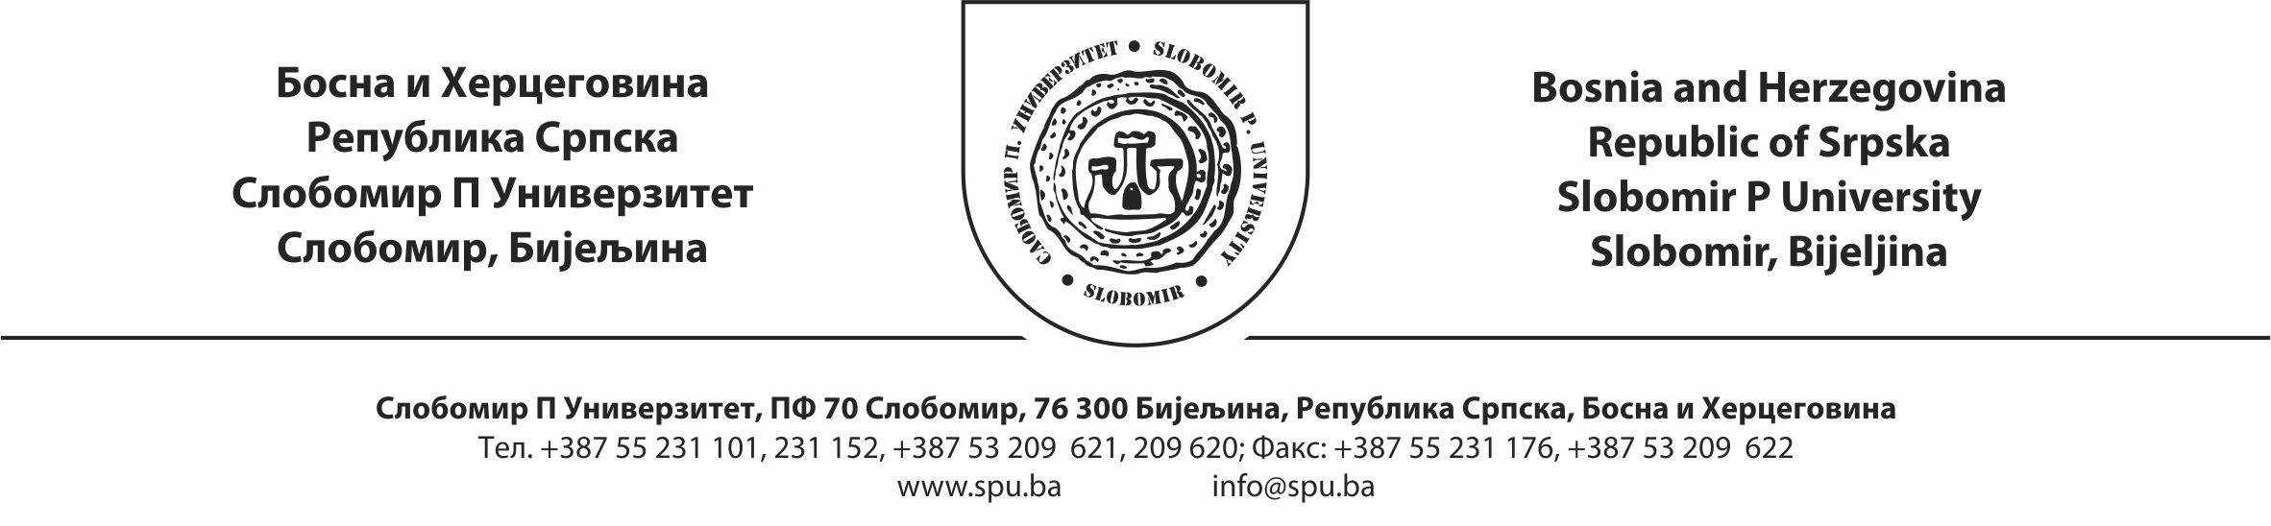

Respected,

We invite you to a MASTER CLASS organized in the framework of the VI SLOBOMIR INTERNATIONAL MUSIC COMPETITION
in the period from 16 - 19 May 2019, which will be held at the Slobomir P University.

MASTER CLASS:
- Jokuthon Mihajlovic, Serbia
- Aleksandra Romanic, Germany
- Dubravka Jovicic, Serbia
- Aida Gavrilova, Spain
- Aleksandra Radosavljevic. Bosnia and Herzegovina
- Neven Sobajic, Serbia

Registration fee for active participation at the master class is 20 euros.
The registration fee for passive participation at the master class is 10 euros.
Payments can be made in accounting Slobomir P University with indication registration fee for the master class.

Completed applications can be mailed to the address:

SLOBOMIR P UNIVERZITET (APPLICATION FOR THE MASETR CLASS ) PF 70, SLOBOMIR, 76300 BIJELJINA, or to e-mail: simcslobomir@gmail.com

Kind regards,

The President of the Expert and Organizing Committee
Dean of the Academy of Arts
Aleksandra Radosavljević, MA, docent

